# 期末模擬考題：圖片型問題練習（第7–11章）含解答

## 📘 題目 1：K-Means 分群視覺化 / K-Means Clustering Visualization

此分群是否合理？應該使用什麼方法選擇最佳 k？

Is this clustering reasonable? What method should be used to select the best number of clusters (k)?

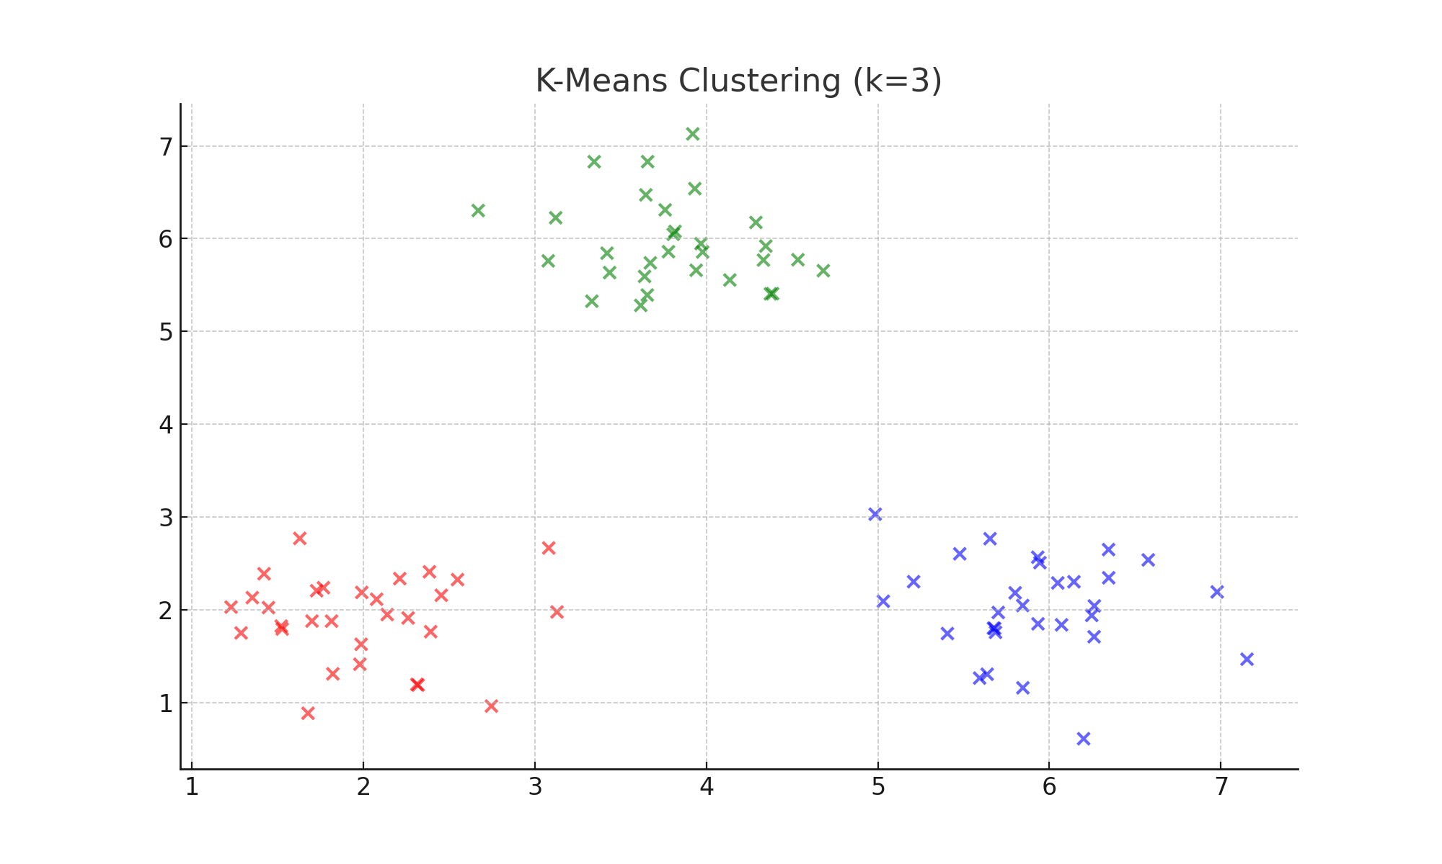

✅ 解答 Answer：

從圖中可以看出三群間有明顯區隔，因此分群合理。可以使用 Silhouette Score 或 Elbow Method 來選擇最佳 k 值。

The clustering appears reasonable as the three clusters are clearly separated. Use Silhouette Score or Elbow Method to select the optimal number of clusters (k).

## 📘 題目 2：Silhouette Score 評估 / Silhouette Score Evaluation

哪個 k 值最佳？若有過多小群會如何？

Which k is the best? What happens if there are too many small clusters?

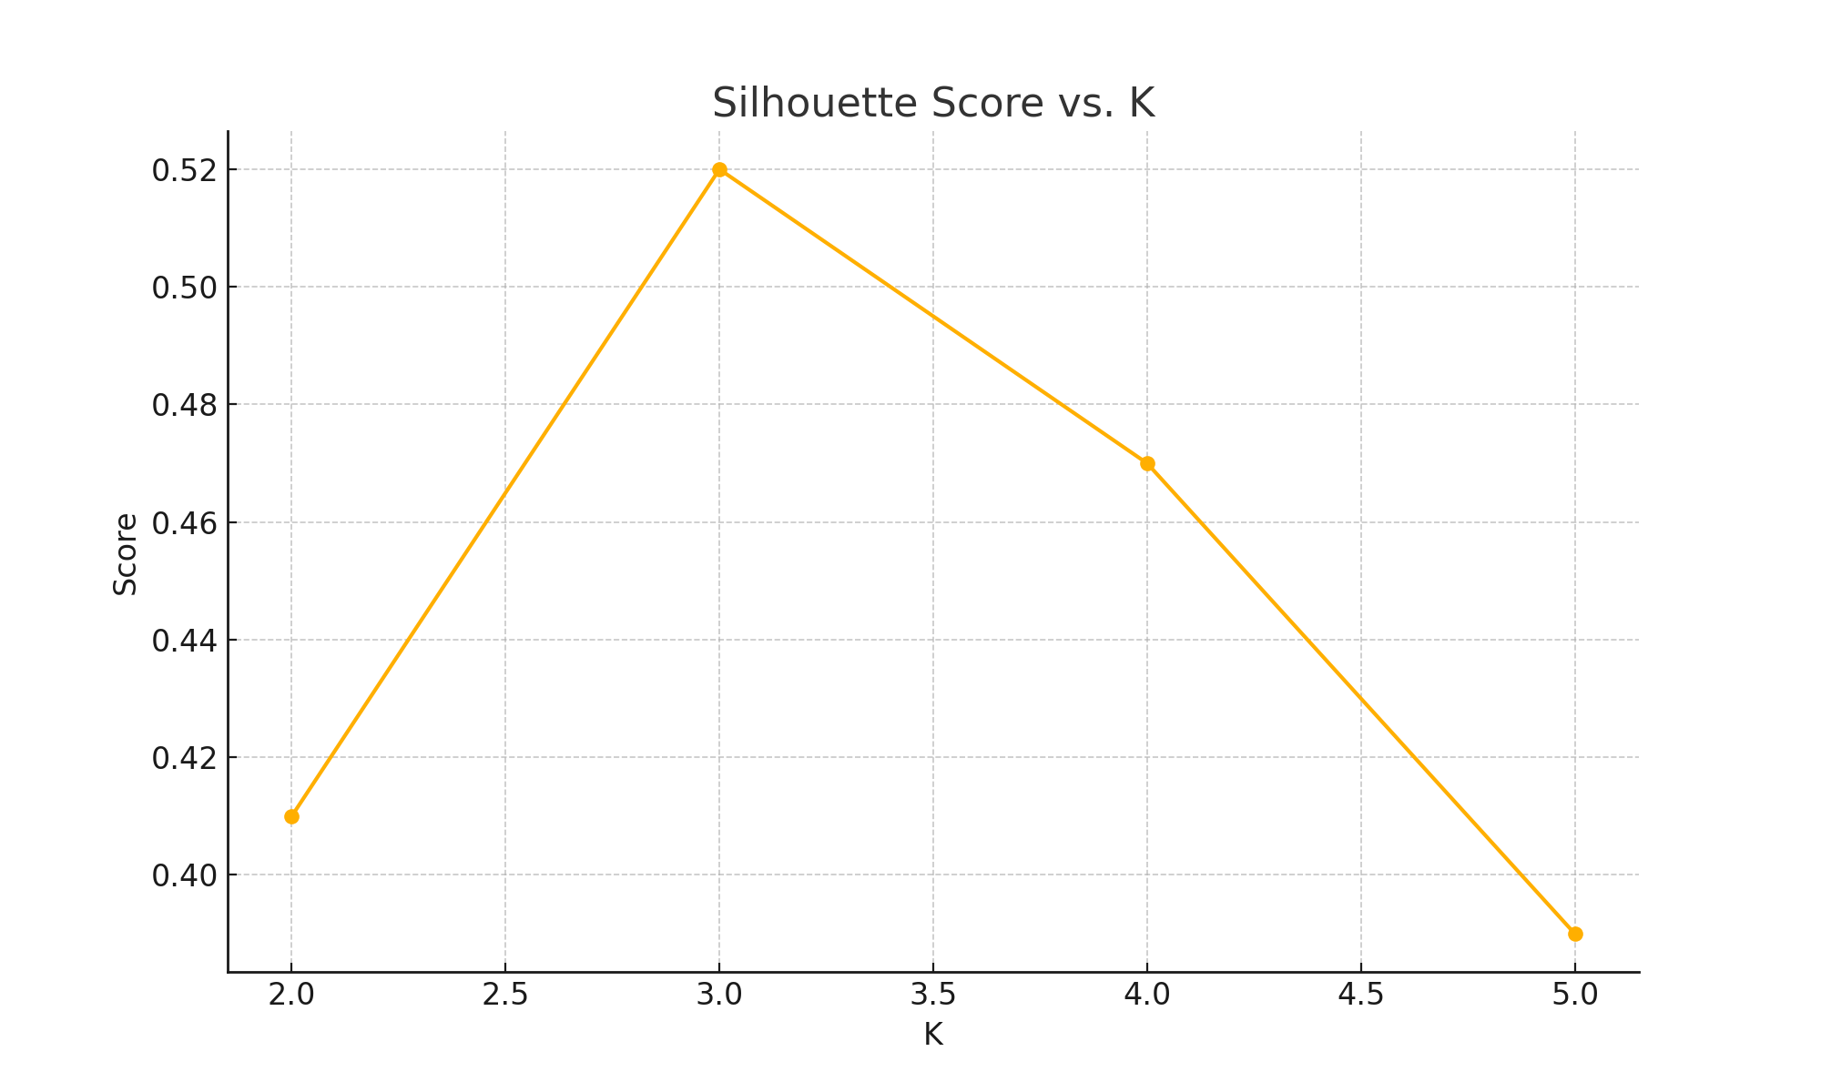

✅ 解答 Answer：

從圖中可見 k=3 時的 Silhouette Score 最高，因此 k=3 為最佳選擇。若分群太多，會造成平均分群品質下降，Score 變低。

The best k is 3, as it yields the highest Silhouette Score. Too many small clusters reduce overall clustering quality and lower the score.

## 📘 題目 3：CNN 結構圖判讀 / CNN Architecture Interpretation

每層功能為何？加入 Dropout 有何好處？

What is the function of each layer? What is the benefit of adding Dropout?

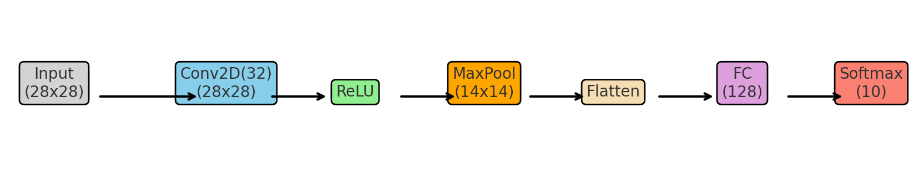

✅ 解答 Answer：

Conv 提取特徵、ReLU 提供非線性、Pool 減少尺寸、FC 負責分類。加入 Dropout 可避免過擬合。

Conv extracts features, ReLU adds non-linearity, Pool reduces spatial size, FC handles classification. Dropout prevents overfitting.

## 📘 題目 4：決策樹路徑推理 / Decision Tree Path Inference

若 Feature1=4, Feature2=3，預測為何？資料太少會造成什麼問題？

If Feature1=4 and Feature2=3, what is the predicted class? What is the risk of having too few samples in a leaf?

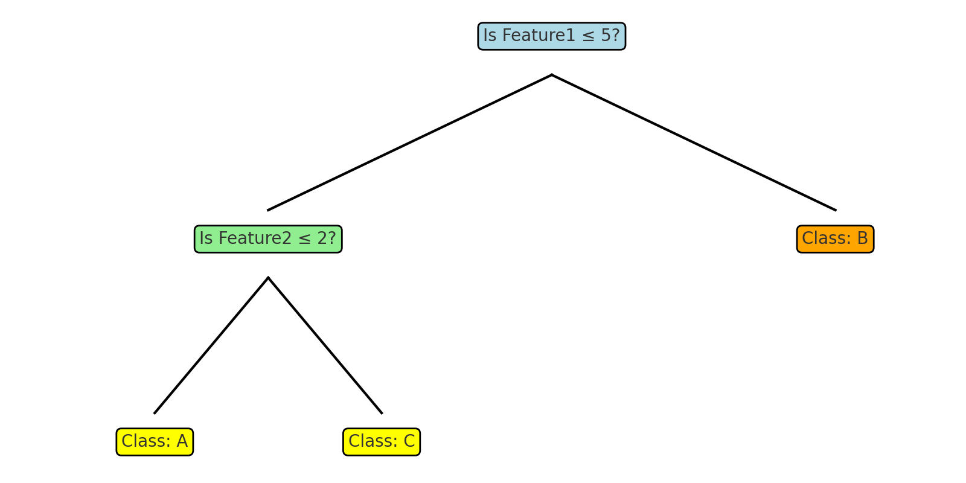

✅ 解答 Answer：

路徑會走左 → 右 → Class C。樣本太少會導致模型過擬合，不具泛化能力。

Path goes left → right → Class C. Too few samples may cause overfitting and poor generalization.

## 📘 題目 5：混淆矩陣分析 / Confusion Matrix Analysis

哪一類預測準確？若要提升精確率與召回率該怎麼做？

Which class is predicted accurately? How to improve both precision and recall?

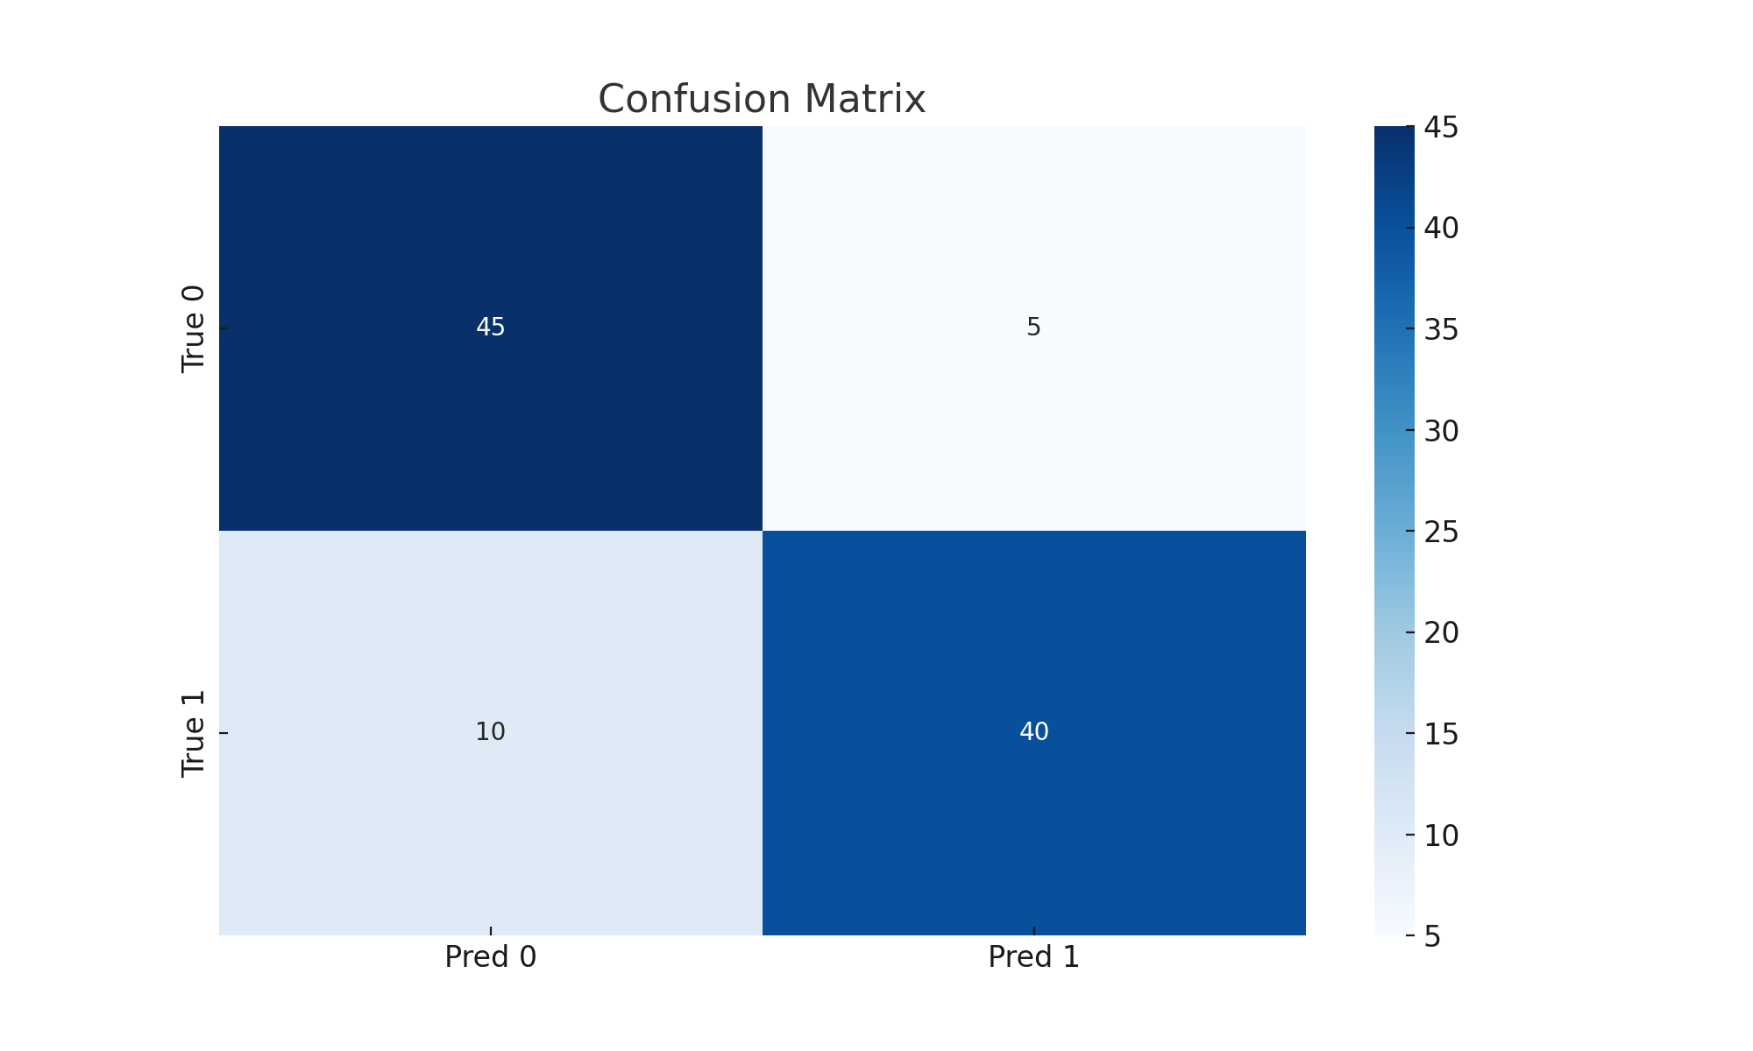

✅ 解答 Answer：

True 0 的準確率較高，Class 1 較常被誤判。可透過調整模型閾值或重新取樣資料來提升表現。

True 0 is more accurately predicted; Class 1 tends to be misclassified. Adjusting thresholds or resampling can help improve performance.